**THE RASPBERRY PI OPERATING SYSTEM**

Your EGB320 kits contain a micro SD card, and a micro SD to SD adapter. The micro SD card will be used to host your Raspberry Pi operating system, as well as any data you choose to store on the Pi throughout the course of this semester. Currently, the micro SD card is blank, and will require you to write an image of a suitable Linux based operating system to it prior to using your Raspberry Pi. There are a number of operating systems which can be used on the Raspberry Pi, particularly Raspbian (debian for Raspberry Pi), and Ubuntu Mate.

We have created a Raspbian Jessie image for EGB320 which contains most of the tools you may require throughout this semester, and this will be made available to you via blackboard for use on your Raspberry Pi’s. Whilst you are not required or obliged to use this image, please be aware the install timeframe for OpenCV can be in the range of 5-10 hours, so if you choose to prepare an image yourself, you will need to allow time for this installation process. This guide will provide instructions for imaging your micro SD card with the provided EGB320 image. If you do wish to download a fresh Raspbian image, without the additional resources installed, the following guides may prove useful.

**Alternative Setup Instructions:**

To download and install Raspbian:

<https://www.raspberrypi.org/documentation/installation/installing-images/>

To download and install Ubuntu Mate:

<https://ubuntu-mate.org/raspberry-pi/>

To install OpenCV3 on a Raspberry Pi 3 (assumes Raspbian Jessie OS)

<https://www.pyimagesearch.com/2016/04/18/install-guide-raspberry-pi-3-raspbian-jessie-opencv-3/>

**1.0 DOWNLOAD THE RASPBERRY PI IMAGE**

The EGB320 Raspbian Jessie image is provided on QUT Blackboard, under INSERT_LOCATION_HERE. Downloading this file will require approximately 16GB of space on your harddrive. Due to the size of the file, we recommend you download the image while connected to QUT or eduroam WiFi. The file we provide will have a ‘.img’ file extension, and is ready to use immediately after download (do not try to extract or uncompress the EGB320 image file, it has not been compressed).

**2.0 DOWNLOAD AN IMAGE WRITING PROGRAM**

**Windows**

For Windows, the simplest disk imaging program is Win32 Disk Imager, which is available for free download at the link below.

<https://sourceforge.net/projects/win32diskimager/>

This is only a 12MB download, so should complete relatively quickly. Once it has downloaded, follow the prompts to install the disk imaging program on your local machine. This should only take a few seconds, and the program should then be ready to launch.

**Linux or Mac OS**

To install the Raspberry Pi image on your micro SD card using Linux or Mac OS, there are a variety of tools available for use. One of the simplest to use is a program called Etcher, which is available on all platforms (however is a much larger download than Win32 so not recommended for Windows).

<https://etcher.io/>

This is an 80MB download, so be wary of this if you are not using QUT WiFi. The file will require extraction after download, but can then be immediately launched.

**3.0 WRITE THE IMAGE TO THE MICRO SD CARD**

To write the image to your micro SD card, simply insert the micro SD card into the SD card adapter, and insert into your computer’s SD card slot. If you do not have an SD card slot, you will need to insert the SD card into an SD to USB adapter.

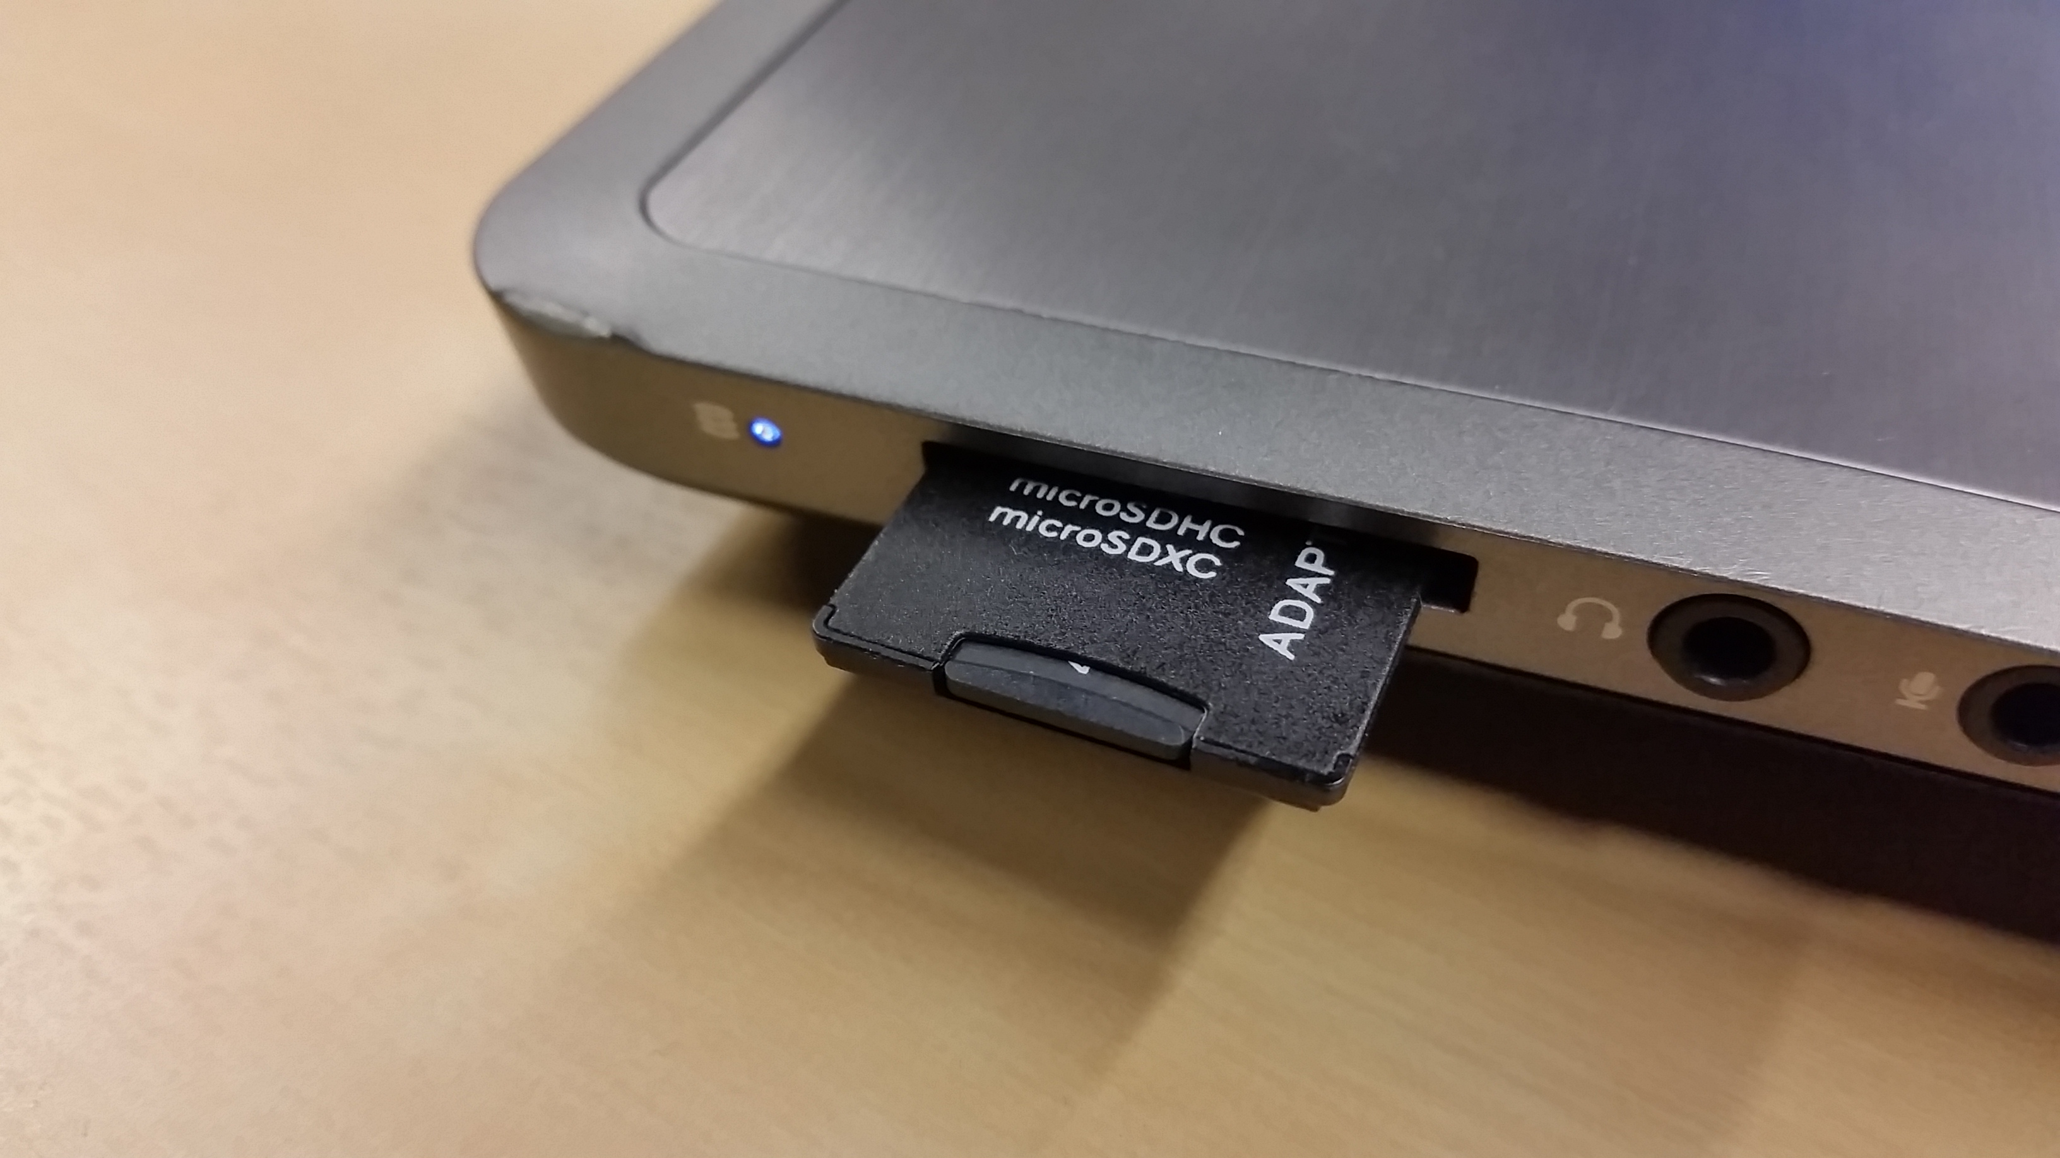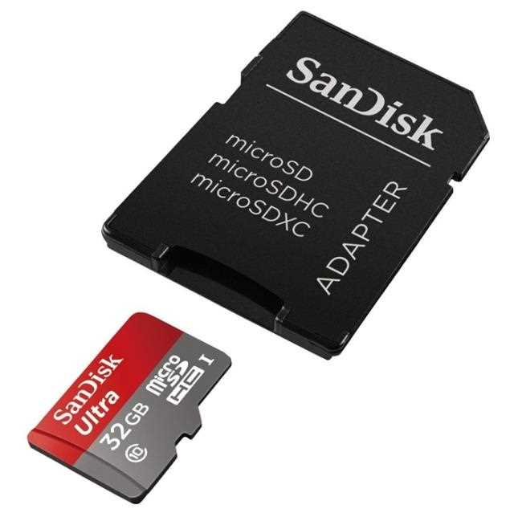

Image sources: <http://hobbyflip.com/content/images/thumbs/0257828_gopro-hero-2-32gb-micro-sd-card-portable-storage-chip-usb-card-reader-combo.jpeg> and <https://32414320wji53mwwch1u68ce-wpengine.netdna-ssl.com/wp-content/uploads/2015/02/Insert_the_SD-Card_into_your_PC.jpg>

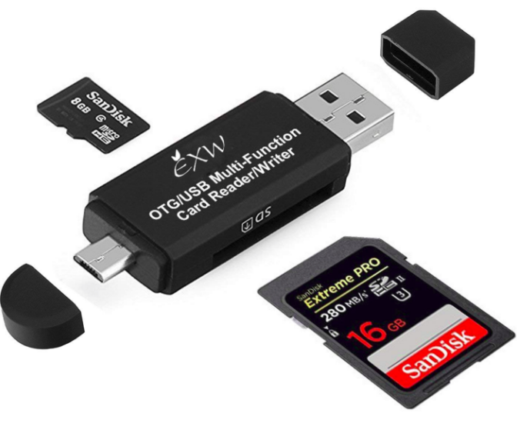

Image source: <https://images-na.ssl-images-amazon.com/images/I/71xt6L9T8PL._SL1417_.jpg>

Open your image writer program, which will be either Win32 Disk Imager or Etcher if you followed the previous steps.

Select the Raspberry Pi image file from your computers file system.

Select the device which you want to write the image to – be very careful to select the correct drive (that of your micro SD card). If you choose the wrong drive, you may wipe and/or damage the device.

Review your selections, ensure you have chosen the correct image file and drive, and click the ‘Flash’ or ‘Write’ button in your imaging program.

Wait for the flash to comlpete. This can typically take about 20 minutes.

Upon completion, eject your devices and insert the micro SD card into your Raspberry Pi. You should now have a working operating system on your Pi!